**TITLE OF THE PROJECT**

***DICTIONARY GUI APP USING PYTHON***

ABSTRACT

This project is about creating an Interactive Word Meaning Dictionary app in Python. Concepts of JSON, File Reading, Python Data Structure and difflib module are being used. For GUI Tkinter the built-in graphical user interface (GUI) interface for all standard Python distributions is used. We are going to build an Interactive Dictionary which lets users search the desired word and its meaning and also provides the aptest word suggestion in case of misspelling or mistype by user. For doing this,we need to create a dataset that contains words and different meanings associated with it. For dataset we used JSON file which is used to store words as keys and meaning as its value. Tkinter is suited for application to a wide variety of areas ranging from small desktop applications, to use in scientific modeling and research endeavors across various disciplines. The purpose of this project is to make GUI Dictionary app using Tkinter.

ACKNOWLEDGEMENT

It is always a pleasure to praised the fine faculty in the LPU University for their sincere guidance I received to uphold my project as well as my skills in it.

First of all, thanks to my parent for giving encouragement, enthusiasm and invaluable assistance to me. Also I want to thanks all the group members . Without all this, I might not be able to complete this subject properly.

Second, I would like to thanks to Dr. Rahul sir ( INT213 faculty ) for give us the opportunity to made such resourceful project. He also gives me their guidance and support.

Finally I apologize all other unnamed who helped me in various ways to have a good project.

CONTENTS

1. INTRODUCTION
2. OBJECTIVES
3. SCREENSHOTS
4. CONCLUSION
5. REFERENCES

INTRODUCTION

* English dictionary application using Python

**Dictionary** in Python is an unordered collection of data values, used to store data values like a map, which unlike other Data Types that hold only single value as an element, Dictionary holds key : value pair. Key value is provided in the dictionary to make it more optimized. Each key-value pair in a Dictionary is separated by a colon :, whereas each key is separated by a ‘comma’.

A Dictionary in Python works similar to the Dictionary in a real world. Keys of a Dictionary must be unique and of immutable data type such as Strings, Integers, and tuples, but the key-values can be repeated and be of any type.

#### Modules needed

* **json[1]:**It comes built-in with python, so there is no need to install it externally.
* **difflib[2]:**This module provides classes and functions for comparing sequences. It also comes built-in with python so there is no need to install it externally.

This part is used for dictionary formation, now we used tkinter[3] for our GUI[4] formation.

GUI programming is an art, and like all art, you need a drawing board to capture your ideas. Tkinter is suited for application to a wide variety of areas ranging from small desktop applications, to use in scientific modeling and research endeavors across various disciplines.

We need to perform following steps to make our Dictionary Application works flawlessly:

* Load JSON file into python where we write our main code.
* Pass that word into a search() function where the code will be looking for the meaning of input word into the data.json file.
* search() function will not just look for the meaning into data.json file but also analyze the word to check if a user somehow mistypes the word and meant something else, which will be making our dictionary interactive.
* Also we have to write the code for our GUI (which totally depends on oneself that how he implements it) and we have to connect it with json file and check on the proximity of word to define.With that we will need two libraries which we previously mentioned: JSON,difflib..

In the code we have used **get_close_matches**[5]() function of **difflib**module inside search() function to analyse the word and making our application interactive.

IDE[6] used for implement this project is Jupyter[7] Notebook.

OBJECTIVES

In our project we should do that a function which takes input from user to enter a word and it will search and display on text bar,if the word is misspelled it will search for the close matches from the data.json file.

Being a pure object oriented programming language, PYTHON is

reliable. Hence, it is advantageous to develop a app in PYTHON.

While making the project we aimed at :

* To make the interface based app using the features of Tkinter.
* To find out the meaning of complex and different type of words present in dictionary.
* To collect new words in dictionary by loading new words and their meaning time to time in data.json file.

The elaborations for tkinter library are (the widgets used in project) :-

1. Buttons
2. Entry
3. Labels
4. Loops and if else are used
5. Text

SCREENSHOTS

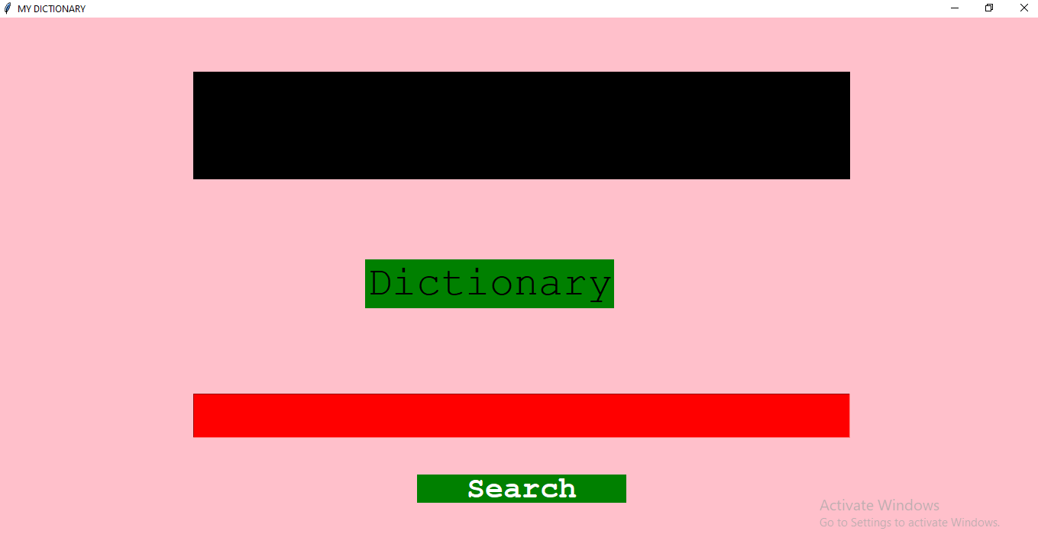

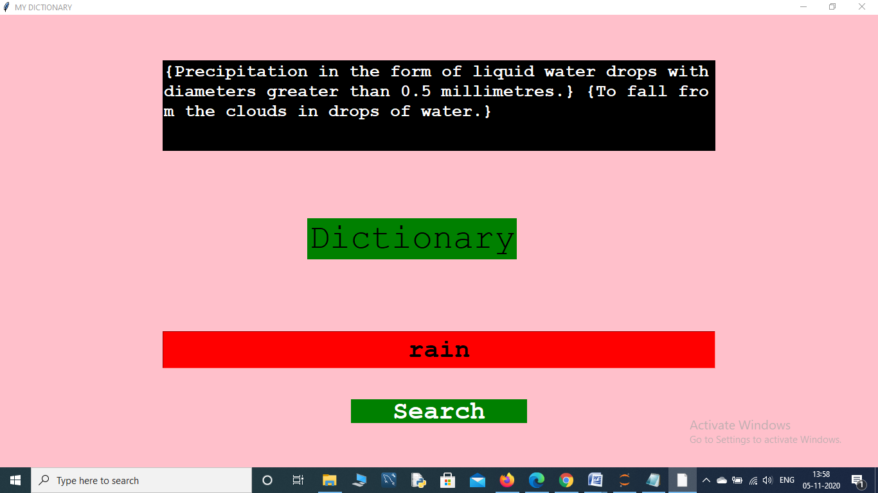

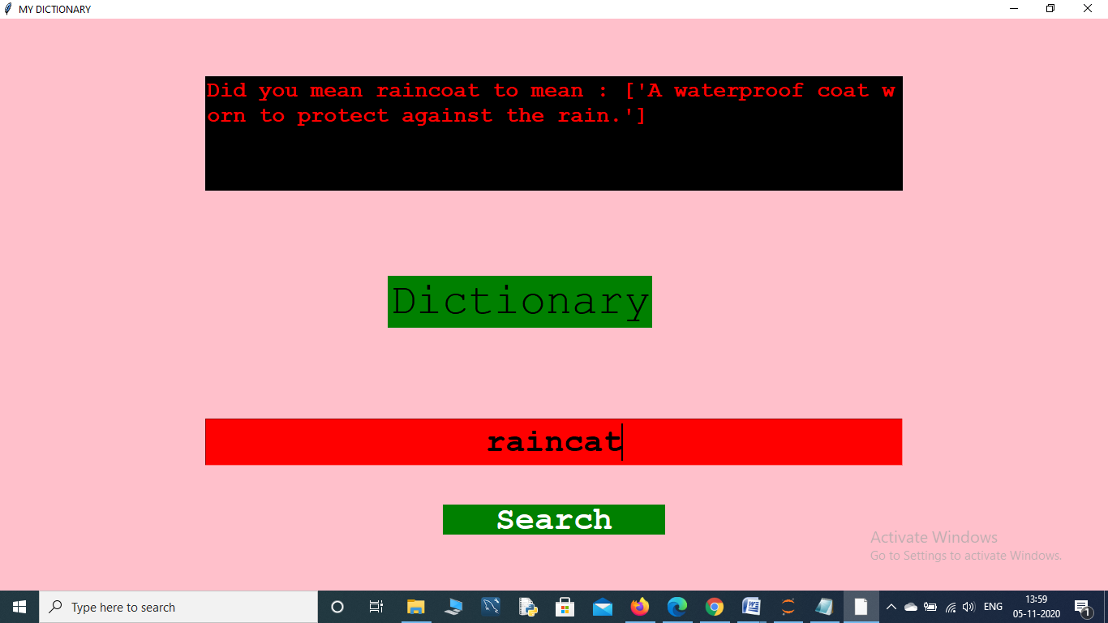

CONCLUSION

So far, we have studied the introduction about our project and came to know about various dictionary topics.

* We have learnt how to use the dictionaries in python.
* We came to know the json and difflib modules and how to implement it.
* The objective of our project is to search the meaning of word in the GUI interface.
* We used normal Tkinter library to create an interface where user can provide inputs and check the results.
* Also, we have provided the better explanation for result.
* We used get close matches of difflib module to analyse the word and making our application interactive.

REFERENCE

* <https://www.geeksforgeeks.org/english-dictionary-application-using-python/>
* <https://www.geeksforgeeks.org/python-gui-tkinter/#:~:text=Out%20of%20all%20the%20GUI,tkinter%20is%20an%20easy%20task>.
* <https://wiki.python.org/moin/>

1. A JSON file is a file that stores simple data structures and objects in JavaScript Object Notation (**JSON**) format, which is a standard data interchange format. It is primarily used for transmitting data between a web application and a server. Here we used JSON file to store words as keys and meaning as its value.
2. **difflib**module provides classes and functions for comparing sequences.
3. Tkinter, is the built-in graphical user interface (GUI) interface for all standard Python distributions.
4. Graphical user interface
5. **get_close_matches***:* Return a list of the best ‘good enough’ matches. Word is a sequence for which close matches are desired (typically a string), and possibilities is a list of sequences against which to match word (typically a list of strings).
6. Integrated Development Environment
7. The **Jupyter Notebook** application allows you to create and edit documents that display the input and output of a Python or R language script